**PIZZA DATABASE SQL QUERIES**

1. **KPI’s**
2. **Total Revenue**

SELECT SUM(total_price) AS Total_Revenue FROM pizza_sales;

**Output:**

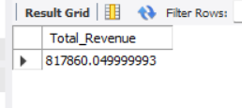

1. **Average order amount**

SELECT SUM(total_price)/ COUNT(DISTINCT order_id) AS Average_order_amount FROM pizza_sales;

**Output:**

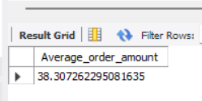

1. **Total Pizza Sold**

SELECT SUM(quantity) AS Total_pizza_sold FROM pizza_sales;

**Output:**

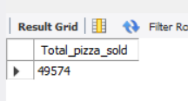

1. **Total Orders**

SELECT COUNT(DISTINCT order_id) AS Total_orders FROM pizza_sales;

**Output:**

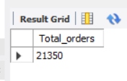

1. **Average Pizza Per Order**

SELECT ROUND(SUM(quantity) / COUNT(DISTINCT order_id),2) AS Avg_pizza_per_order FROM pizza_sales;

**Output:**

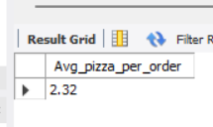

1. **CHART REQUIREMENTS**
2. **Daily Trends For Total Orders**

SELECT DAYNAME(DAYOFWEEK( order_date)) AS Order_day , COUNT(DISTINCT order_id) AS Total_orders FROM pizza_sales GROUP BY Order_day;

**Output:**

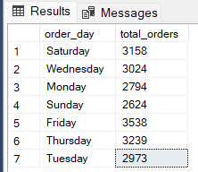

2. **Monthly Trends For Total Orders.**

SELECT DAYNAME(MONTH( order_date)) AS Order_day , COUNT(DISTINCT order_id) AS Total_orders FROM pizza_sales GROUP BY Order_day;

**Output:**

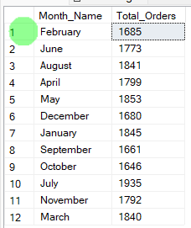

1. **% of Sales by Pizza Category**

SELECT

pizza_category,

SUM(total_price) * 100 / (SELECT

SUM(total_price)

FROM

pizza_sales) AS Total_Sales

FROM

pizza_sales

GROUP BY pizza_category;

**Output:**

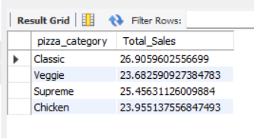

1. **% of Sales By Pizza Size**

SELECT

pizza_size,

SUM(total_price) * 100 / (SELECT

SUM(total_price)

FROM

pizza_sales) AS Total_Sales

FROM

pizza_sales

GROUP BY pizza_size;

**Output:**

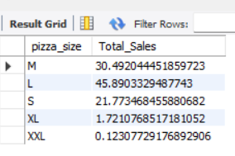

1. **Top 5 best sellers by Revenue**

SELECT

pizza_name, SUM(total_price) AS Revenue

FROM

pizza_sales

GROUP BY pizza_name

ORDER BY Revenue DESC

LIMIT 5;

**Output:**

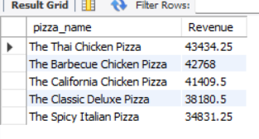

1. **Bottom 5 sellers by Revenue**

SELECT

pizza_name, SUM(total_price) AS Revenue

FROM

pizza_sales

GROUP BY pizza_name

ORDER BY Revenue

LIMIT 5;

**Output:**

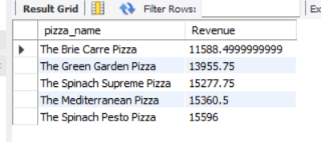

1. **Top 5 sellers by Total Quantity**

SELECT

pizza_name, SUM(quantity) AS Total_Quantity

FROM

pizza_sales

GROUP BY pizza_name

ORDER BY Total_Quantity DESC

LIMIT 5;

**Output:**

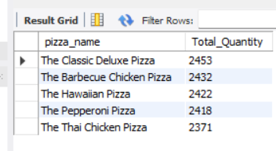

1. **Bottom 5 sellers by Total Quantity**

SELECT

pizza_name, SUM(quantity) AS Total_Quantity

FROM

pizza_sales

GROUP BY pizza_name

ORDER BY Total_Quantity

LIMIT 5;

**Output:**

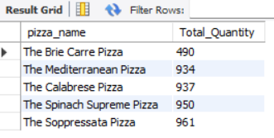

1. **Top 5 sellers by Total Order**

SELECT

pizza_name, COUNT(DISTINCT order_id) AS Total_order

FROM

pizza_sales

GROUP BY pizza_name

ORDER BY Total_order DESC

LIMIT 5;

**Output:**

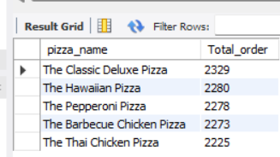

1. **Bottom 5 sellers by Total Order**

SELECT

pizza_name, COUNT(DISTINCT order_id) AS Total_order

FROM

pizza_sales

GROUP BY pizza_name

ORDER BY Total_order

LIMIT 5;

**Output:**

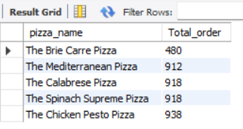

**DASHBOARD**

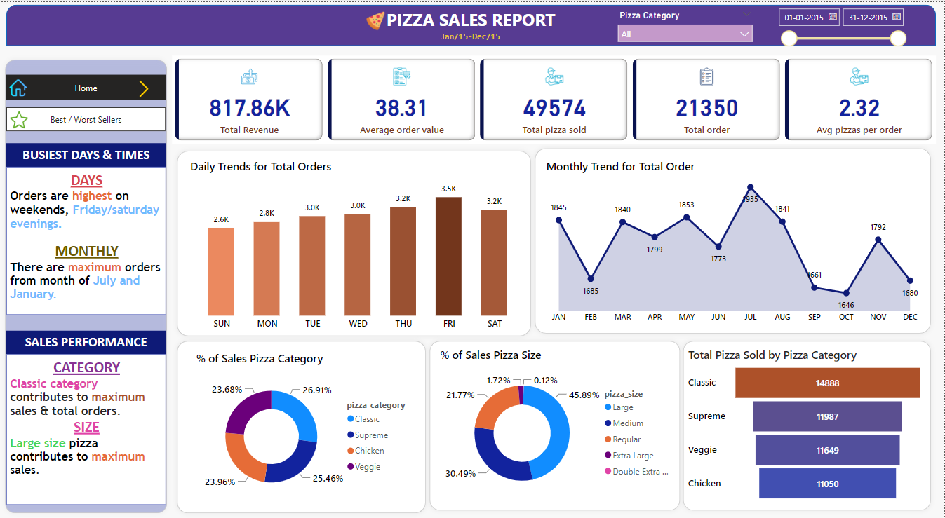

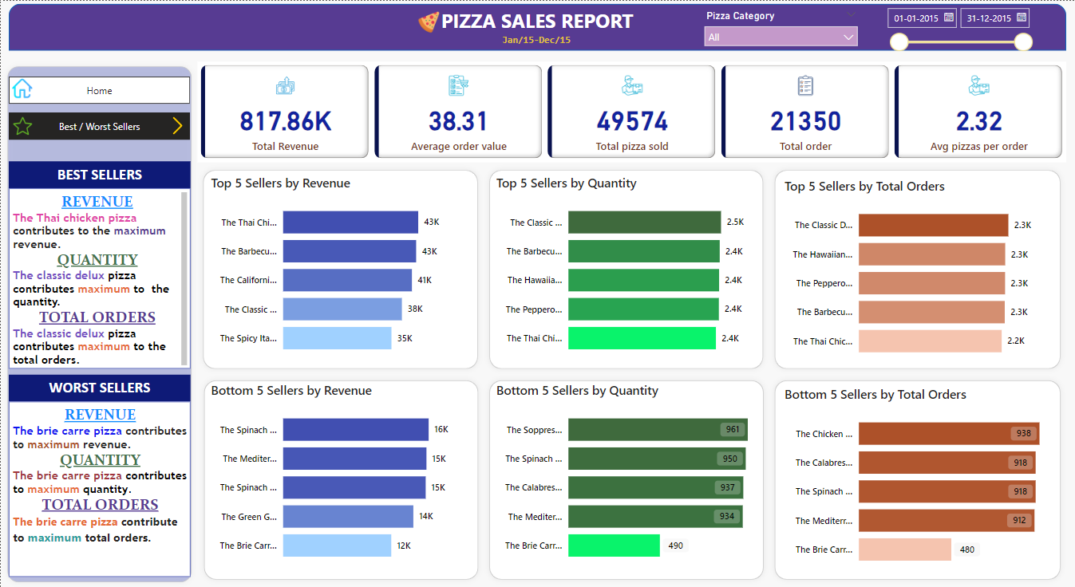

GITHUB LINK- <https://github.com/aakashgupta10>